
QUALITY ALERT

Customer: Seaway Date: August 21, 2019
Die: 4683 Colour: All
Type of Complaint: Seaway Reject

Q.A # Q.I.R # CUSTOMER NCR #

Description: Off square distorting the internal walls too much making difficult to insert foam and hard to weld
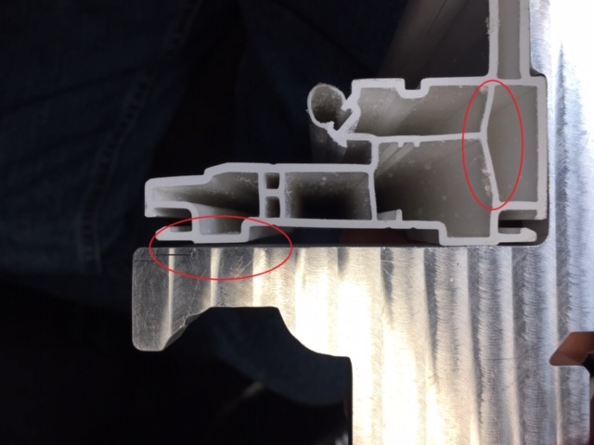
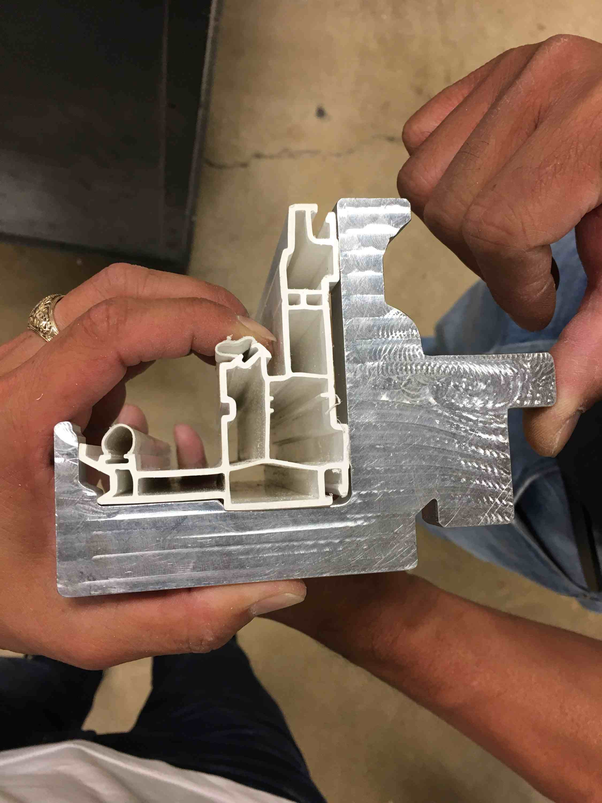

CHECK WITH JIG – MAKE SURE SIT FLAT

BY SIGNING BELOW, YOU ACKNOWLEDGE THE PROBLEM ABOVE AND AGREE TO MONITOR THIS ISSUE IN FUTURE PRODUCTION RUNS.
DAY SHIFT |  | AFTERNOON SHIFT |  | NIGHT SHIFT
NAME | SIGNATURE | NAME | SIGNATURE | NAME | SIGNATURE

